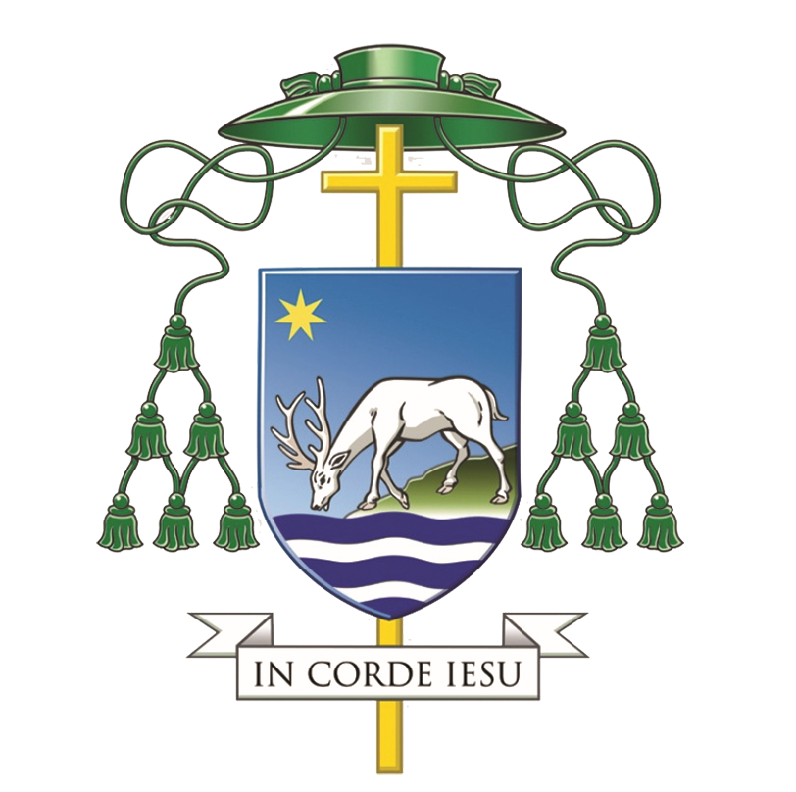 | 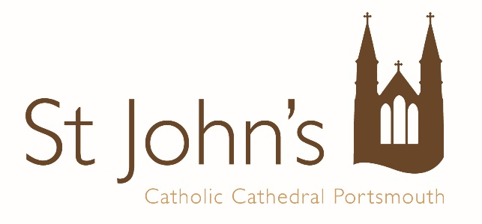
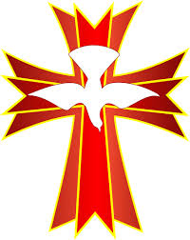

Celebration of the Sacrament of Confirmation
for
xxxxx Pastoral Area
Principal Celebrant:
Rt. Rev. Philip Egan, Bishop of Portsmouth
Date
Time

Acknowledgements

Hymns and Music are reproduced under Calamus licence 054

Excerpts from the English translation of The Roman Missal © 2010, International Commission on English in the Liturgy Corporation. All rights reserved.

English translation of The Order of Confirmation © 2013, International Commission on English in the Liturgy Corporation. All rights reserved.

Photography is not permitted during the Mass other than by the official photographer.

Please ensure all mobile phones are switched off before Mass begins.

Toilets may be found at the far end of the Cathedral Discovery Centre.

Please note that the front row of pews is reserved for the sick and disabled only.

Please help us to keep a period of silence and reverence during the ten minutes before Mass and use the time to prepare yourself for Mass and pray for our candidates.

Gathering Chant

Please stand when the bell rings.

Entrance Hymn

INTRODUCTORY RITES

Sign of the Cross and Greeting

Bishop: In the name of the Father, and of the Son, and of the Holy  Spirit,
All: Amen.
Bishop: Peace be with you.
All: And with your spirit.

Bishop Philip welcomes all present and introduces the celebration.

Penitential Act

Blessing and Sprinkling with Water and Salt

Holy Water is a symbol of cleansing and a reminder of our Baptism. The Blessing and Sprinkling of Holy Water is therefore used as the Penitential Act at this Mass.

During the sprinkling, we sing:

Gloria

Glory to God in the highest,
and on earth peace to people of good will.
We praise you,
we bless you,
we adore you,
we glorify you,
we give you thanks for your great glory,
Lord God, heavenly King,
O God, almighty Father.
Lord Jesus Christ, Only Begotten Son,
Lord God, Lamb of God, Son of the Father,
you take away the sins of the world,
have mercy on us;
you take away the sins of the world,
receive our prayer;
you are seated at the right hand of the Father,
have mercy on us.
For you alone are the Holy One,
you alone are the Lord,
you alone are the Most High,
Jesus Christ,
with the Holy Spirit,
in the glory of God the Father.
Amen.

Collect

Bishop: Let us pray:

May the Paraclete who proceeds from you, we pray, O Lord, enlighten our minds and lead us into all truth, just as your Son has promised.
Who lives and reigns with you in the unity of the Holy Spirit, one God, for ever and ever.
All: Amen.

Please sit

LITURGY OF THE WORD

First Reading Acts 2:1-11

They were filled with the Holy Spirit and began to speak.

When Pentecost day came round, they had all met in one room, when suddenly they heard what sounded like a powerful wind from heaven, the noise of which filled the entire house in which they were sitting; and something appeared to them that seemed like tongues of fire; these separated and came to rest on the head of each of them. They were all filled with the Holy Spirit and began to speak foreign languages as the Spirit gave them the gift of speech.

Now there were devout men living in Jerusalem from every nation under heaven, and at this sound they all assembled, each one bewildered to hear these men speaking his own language. They were amazed and astonished. ‘Surely’ they said ‘all these men speaking are Galileans? How does it happen that each of us hears them in his own native language? Parthians, Medes and Elamites; people from Mesopotamia, Judaea and Cappadocia, Pontus and Asia, Phrygia and Pamphylia, Egypt and the parts of Libya round Cyrene; as well as visitors from Rome – Jews and proselytes alike – Cretans and Arabs; we hear them preaching in our own language about the marvels of God.’

Reader: The Word of the Lord.
All: Thanks be to God.

Responsorial Psalm Psalm 103

Response: Send forth your spirit, O Lord,
and renew the face of the earth.

Bless the Lord, my soul!
Lord God, how great you are,
How many are your works, O Lord!
The earth is full of your riches. R/.

You take back your spirit, they die,
returning to the dust from which they came.
You send forth your spirit, they are created;
and you renew the face of the earth. R/.

May the glory of the Lord last for ever!
May the Lord rejoice in his works!
May my thoughts be pleasing to him.
I find my joy in the Lord. R/.
Second Reading 1 Corinthians 12:3-7, 12-13

In the one Spirit we were all baptised.

No one can say, ‘Jesus is Lord’ unless he is under the influence of the Holy Spirit.

There is a variety of gifts but always the same Spirit; there are all sorts of service to be done, but always to the same Lord; working in all sorts of different ways in different people, it is the same God who is working in all of them. The particular way in which the Spirit is given to each person is for a good purpose.

Just as a human body, though it is made up of many parts, is a single unit because all these parts, though many, make one body, so it is with Christ. In the one Spirit we were all baptised, Jews as well as Greeks, slaves as well as citizens, and one Spirit was given to us all to drink.

Reader: The Word of the Lord.
All: Thanks be to God.

Please Stand

Gospel Acclamation

Alleluia, Alleluia!
Come, Holy Spirit, fill the hearts of your faithful,
and kindle in them the fire of your love.
Alleluia!

Gospel John 20:19-23

As the Father sent me, so am I sending you: receive the Holy Spirit.

Deacon: The Lord be with you.
All: And with your spirit.
Deacon: A reading from the holy Gospel according to John.
All: Glory to you, O Lord.

In the evening of the first day of the week, the doors were closed in the room where the disciples were, for fear of the Jews. Jesus came and stood among them. He said to them, ‘Peace be with you’, and showed them his hands and his side. The disciples were filled with joy when they saw the Lord, and he said to them again, ‘Peace be with you.
‘As the Father sent me,
so am I sending you.’

After saying this he breathed on them and said:
‘Receive the Holy Spirit.
For those whose sins you forgive,
they are forgiven;
for those whose sins you retain,
they are retained.’

Deacon: The Gospel of the Lord.
All: Praise to you, Lord Jesus Christ.

At the conclusion of the proclamation of the Gospel, the Deacon does not venerate the Book of Gospels but takes it to Bishop Philip for him to venerate and he will then bless the people with it. Please remain standing for this.

Please sit after the Bishop has blessed the people with the Book of the Gospels.

Presentation of the Candidates

A catechist or the Co-ordinating Pastor will now ask the candidates to stand and will present the candidates to the Bishop:

Would the candidates for Confirmation please stand.

The candidates stand and remain in their places.

Most Reverend Father, on behalf of the xxxxx Pastoral Area I present to you these Candidates for the Sacrament of Confirmation.

Bishop Philip will greet the candidates and then invite them to sit.

Homily

RITE OF CONFIRMATION

Renewal of Baptismal Promises

The candidates stand and remain in their places for the renewal of baptismal promises.

Bishop: Do you renounce Satan, and all his works and empty promises?
Candidates: I do.

Bishop: Do you believe in God, the Father almighty, Creator of heaven and earth?
Candidates: I do.
Bishop: Do you believe in Jesus Christ, his only Son, our Lord, who was born of the Virgin Mary, suffered death and was buried, rose again from the dead and is seated at the right hand of the Father?
Candidates: I do.

Bishop: Do you believe in the Holy Spirit, the Lord, the giver of life, who today through the Sacrament of Confirmation is given to you in a special way just as he was given to the Apostles on the day of Pentecost?
Candidates: I do.

Bishop: Do you believe in the holy Catholic Church, the communion of saints, the forgiveness of sins, the resurrection of the body, and life everlasting?
Candidates: I do.

Bishop: This is our faith. This is the faith of the Church. We are proud to profess it in Christ Jesus our Lord.
All: Amen.

Laying on of hands

The candidates come forward, under the direction of the stewards, along the sanctuary steps and stand facing the bishop for the Laying on of hands. Joined by the concelebrating priests, Bishop Philip, facing the people and with hands joined prays. He may use these words:

Bishop: Dearly beloved, let us pray to God the almighty Father for these, his adopted sons and daughters, already born again to eternal life in Baptism, that he will graciously pour out the Holy Spirit upon them, to confirm them with his abundant gifts, and through his anointing conform them more fully to Christ, the Son of God.
All pray in silence for a while. The Bishop and priests extend their hands over the candidates.

Bishop: Almighty God, Father of our Lord Jesus Christ, who brought these your servants to new birth by water and the Holy Spirit, freeing them from sin: send upon them, O Lord, the Holy Spirit, the Paraclete; give them the spirit of wisdom and understanding, the spirit of counsel and fortitude, the spirit of knowledge and piety; fill them with the spirit of the fear of the Lord. Through Christ our Lord.
All: Amen.

Anointing with Chrism

Each candidate, guided by the ushers, goes to kneel before the Bishop who is seated at his Cathedra.

Each Sponsor gives the name card to the Deacon or priest assisting the Bishop. The Sponsor places their right hand on the candidate’s right shoulder. Bishop Philip makes the sign of the cross on the candidate’s forehead with the oil of Chrism saying:

Bishop: [Name], be sealed with the gift of the
Holy Spirit.
Candidate: Amen.
Bishop: Peace be with you.
Candidate: And with your spirit.

During which we sing the following:

LITURGY OF THE EUCHARIST

Offertory Hymn

Please stand to be censed by the Deacon.
Bishop: Pray, brothers and sisters, that my sacrifice and yours may be acceptable to God, the almighty Father.
All: May the Lord accept the sacrifice at your hands for the praise and glory of his name, for our good and the good of all his holy Church.

Prayer over the Offerings

Bishop: Accept the oblation of your family, we pray, O Lord, that those who have received the gift of the Holy Spirit may keep safe what they have received and come to eternal rewards. Through Christ our Lord.
All: Amen.

THE EUCHARISTIC PRAYER

Bishop: The Lord be with you.
All: And with your spirit.
Bishop: Lift up your hearts.
All: We lift them up to the Lord.
Bishop: Let us give thanks to the Lord our God.
All: It is right and just.

Preface of the Holy Spirit

Sanctus

Holy, Holy, Holy Lord God of hosts.
Heaven and earth are full of your glory.
Hosanna in the highest.
Blessed is he who comes in the name of the Lord.
Hosanna in the highest.

Please kneel

EUCHARISTIC PRAYER III

Memorial Acclamation

Bishop: The mystery of faith.
All: We proclaim your Death, O Lord,
and profess your Resurrection
until you come again.

Doxology

Bishop: Through him, and with him, and in him, O God,
almighty Father, in the unity of the Holy Spirit,
all glory and honour is yours, for ever and ever.
All: Amen.

THE COMMUNION RITE

Please stand

Bishop: At the Saviour’s command and formed by divine teaching, we dare to say:

All: Our Father, who art in heaven, hallowed be thy name; thy kingdom come, thy will be done on earth as it is in heaven. Give us this day our daily bread, and forgive us our trespasses, as we forgive those who trespass against us; and lead us not into temptation but deliver us from evil.

Bishop: Deliver us, Lord, we pray, from every evil, graciously grant peace in our days, that, by the help of your mercy, we may be always free from sin and safe from all distress, as we await the blessed hope and the coming of our Saviour, Jesus Christ.

All: For the kingdom, the power and the glory are yours now and for ever.

Bishop: Lord Jesus Christ, who said to your Apostles: Peace I leave you, my peace I give you, look not on our sins, but on the faith of your Church, and graciously grant her peace and unity in accordance with your will. Who live and reign for ever and ever.

All: Amen.

Bishop: The peace of the Lord be with you always.

All: And with your Spirit.

Deacon: Let us offer each other the sign of peace.

All exchange the customary sign of peace with those immediately around them.

Agnus Dei

Lamb of God, you take away the sins of the world, have mercy on us.
Lamb of God, you take away the sins of the world, have mercy on us.
Lamb of God, you take away the sins of the world, grant us peace.

Please kneel

Bishop: Behold the Lamb of God, behold him who takes away the sins of the world. Blessed are those called to the supper of the Lamb.
All: Lord, I am not worthy that you should enter under my roof, but only say the word and my soul shall be healed.

Communicants are reminded to make an act of reverence before receiving Holy Communion and to consume the Sacred Host immediately upon its reception.

Those not in full communion with the Catholic Church – and those not receiving Holy Communion - are invited to make an act of ‘Spiritual Communion’ (see prayer below). You may wish to complete this by going forward to receive a blessing from the priest or deacon. Please indicate that you wish to receive a blessing by crossing your arms over your chest.

SPIRITUAL COMMUNION

My Jesus, I believe that you are present in this Holy Sacrament of the altar. I love you above all things and I passionately desire to receive you into my soul. Since I cannot now receive you sacramentally, come spiritually into my soul so that I may unite myself wholly to you now and forever. Amen. (Based on a prayer of St Alphonsus Liguori)

Communion Hymns

Please stand

Prayer after Communion

Bishop: Pour on us, O Lord, the Spirit of your love and, in your kindness, make those you have nourished by this one heavenly Bread one in mind and heart. Through Christ our Lord.
All: Amen.

CONCLUDING RITE

Bishop: The Lord be with you.
All: And with your spirit.
Bishop: Blessed be the name of the Lord.
All: Now and forever.
Bishop: Our help is in the name of the Lord.
All: Who made heaven and earth.
Bishop: May almighty God bless you, the Father,  and the Son,  and the Holy  Spirit.
All: Amen.
Deacon: Go and announce the Gospel of the Lord.
All: Thanks be to God.

Recessional Hymn

At the end of Mass Bishop Philip will return to the front of the sanctuary for a group photo with the newly confirmed who are asked to assemble there following the conclusion of the recessional hymn.

Please pray for our Candidates

INSERT NAMES

